

prince Sultan University
Women’s College
College of Business Administration
Final Report for Co-Op program Training
Course Code: Finance 420

by: Aisha Alajaji
by: Dr.Nadisah Zakaria
21 March,2019

TABLE OF CONTENTS
Acknowledgements 1
INTRODUCTION 2
a. COMPANY PROFILE 3
b. WORK PLAN 4
PROJECTS&ACTIVITIES 5
fIELD EXPERIENCES 6
- aCHIEVMENT 7
- challenges 8
- relevent education 9
conclusion 10
- overall xperiences 11
- recomendations 12
references 13
appendices 14

I. Acknowledgment

As a matter of first importance, I am appreciative and thankful to my God for helping me and blessing me in each and every obstacle to go thru in this long journey. Besides, I would like to express my great thankful for my parents for their continuous encouragement, trust and support without which this achievement would not be possible.

Moreover, I would like to thank Prince Sultan University – College of Business Administration faculty for their exemplary guidance, monitoring and constant encouragement throughout the course of my study. I would also like to thank my academic advisor Dr. Nadisah Zakaria for all the valuable guidance and advices she provided me through my Co-Op training at TAQNIA.

Lastly, I would also like to thank everyone who contributed to make my training unforgettable, valuable, and informative experience. I have really enjoyed this opportunity and gained knowledge, experiences and skills from qualified employees with higher level of expertise, which has provided me with many outcomes that will help me later on in my career, and I am obliged to my colleagues in TAQNIA, for the valuable information provided by them in their respective fields. I am grateful for their cooperation during the period of my internship.
II. Introduction
As we know that Co-Op training have a big influence on the students since we apply all the knowledge and skills we learned through the years in college. I think it’s important for each student to have a good training by linking the theoretical information we learned with real life situations in a good and correct way, working has really changed a lot of things in me in many different ways, the way I think, the way I communicate, and specially my social life in this long beautiful journey. It was a new experience and a new journey which I had learned a lot from and loved it for sure. Working in the first place is an achievement in life and when you start it you'll keep progressing until you'll reach your goal. for this reason, we must choose where to apply our coop carefully, and make sure to get the most of it.
As a part of graduation requirement student at Prince Sultan University (College of Business Administration) specializing in Finance should engage in Co-Op training program for 28 weeks. This program is structured educational strategy, integrating the theoretical knowledge learned in the classrooms with real world experiences.
My Co-Op training experience at TAQNIA was full of knowledge and new skills. In the training period I learned new skills through using new systems and dealing with different personalities, I also gained new knowledge and confidence through performing many tasks individually. In this report I will be describing in detail about my Co-Op experience, challenges that I have faced and my future plans.
- Company Profile

Saudi Technology Development and Investment Company (TAQNIA) was established in 2011 and is the technology arm of the Kingdom of Saudi Arabia. Based in Riyadh, TAQNIA, its subsidiaries and Business Units are fully owned by the Public Investment Fund (PIF) and seek to diversify the Saudi economy through investing in promising startups, technology localization, and creating a knowledge-based economy. TAQNIA is also fully aligned with the Kingdom’s Vision 2030, which shares identical goals as TAQNIA.
Objectives

TAQNIA creates value from technology through investments, partnerships, and localization to accelerate the diversification of the Saudi economy and to help create an innovative ecosystem in Saudi Arabia. TAQNIA will achieve its vision by investing in local and global technologies and actively engaging in their development and growth into economically sustainable organizations. To that end, TAQNIA has set three main objectives to achieve its potential economic effects: transfer technology, diversify the economy, and create high-skilled jobs.
Vision

“To drive accelerated diversification of the Kingdom’s economy through knowledge-based industries, thereby creating value-adding jobs as well as to help create an innovative ecosystem in Saudi Arabia.”

Mission
“TAQNIA will achieve its vision by investing in local and international technologies while engaging actively in the development and growth of those technologies to prosper into economically sustainable enterprises.”
Values
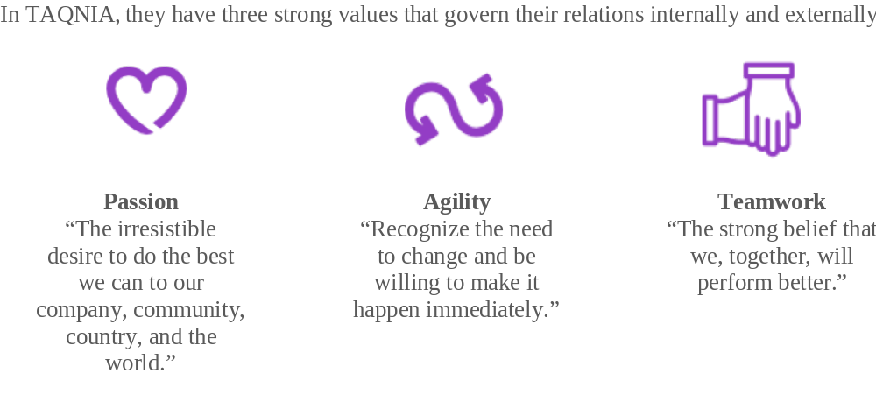

Subsidiaries
TAQNIA is a holding company of the following twelve subsidiaries:

- Engineering Technology Services Company (TAQNIA Services).
- Advanced Water Technology (AWT).
- Defense and Security Technologies.
- TAQNIA for Robotics and Smart Systems.
- Research Products Development Company (RPDC).
- TAQNIA Space.
- TAQNIA Aeronautics.
- TAQNIA Cyber.
- TAQNIA Energy.
- TAQNIA Advanced Materials (TAM).
- Business Incubators and Accelerators Company (BIAC).
- TAQNIA International.

To learn more about TAQNIA, please click here.
Finance department structure

- Work Plan
On the first day of training I had a meeting with two of the Finance staff, who introduced me to the TAQNIA, explained our duties and our rights. They assigned me under VAT&TAX and Projects. My manager requested me to know everything about Filing room which how to save their file by ensuring that each entries paper supported by their documents, arrange papers in the file by serial number and make sure there are no missing paper. Also, she assigned me to practice how to use ERP system in finance module. As s part of the finance team my responsibilities include:
General responsibilities:
- Working on filing system.
- Do manual general ledger entries in ERP and payroll journal voucher.
- write cover letter for new invoice for project.
- Bank reconciliation for each month.
Specific responsibilities:
- make establishment of new projects in the ERP system and Establish new invoice for each project.
- Exemption VAT& Tax from foreign remittances and Submit their reports in GAZT website.
- Administrative assistance.

Projects & Activities
- Account Receivables:
When the company has assigned contract with customer we create customer account in ERP (enterprise resource planning) then create a project number for that contract. after, we issue sale invoice including VAT. Then we calculate the cost and revenue. we receive invoice amount (collection) even in transfer or cheque. To keep control we prepare cost report mentioning the remaining from the contract. On monthly wise we provide project manager.
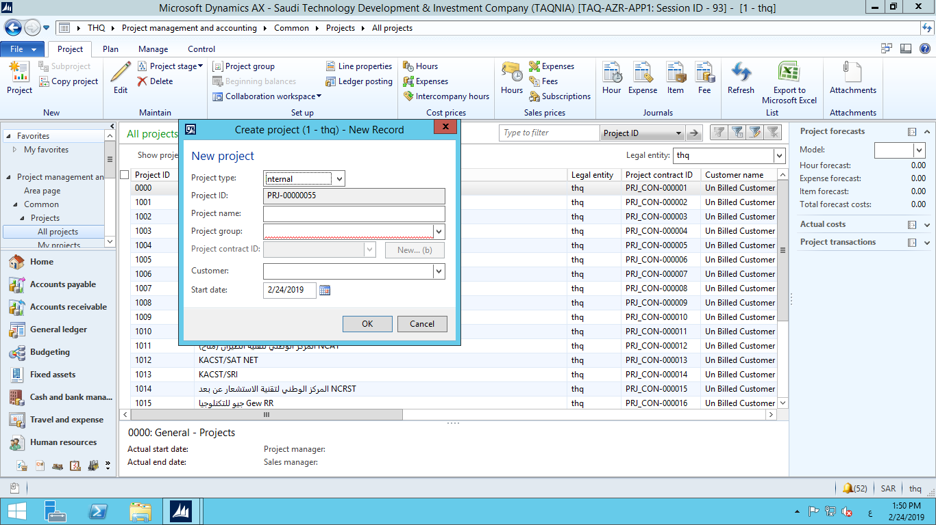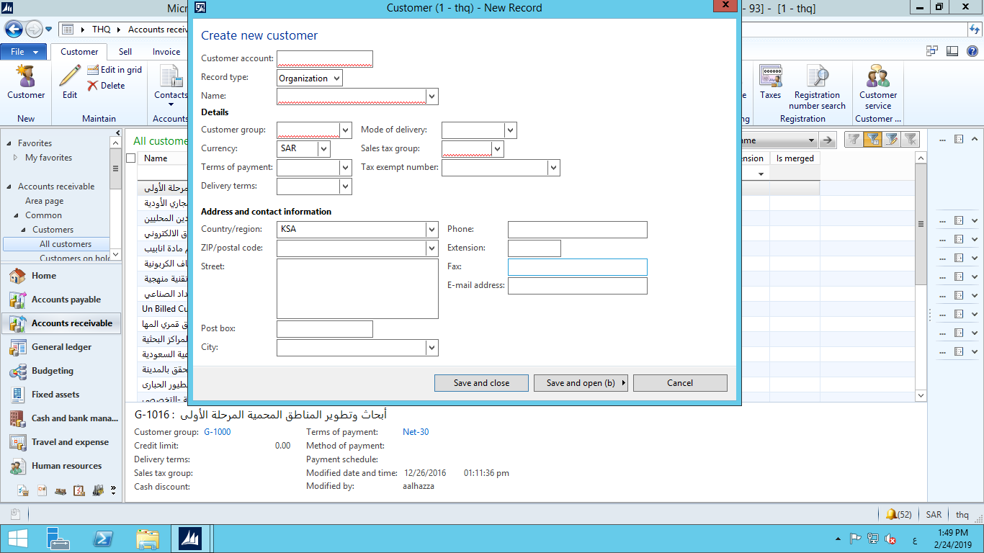
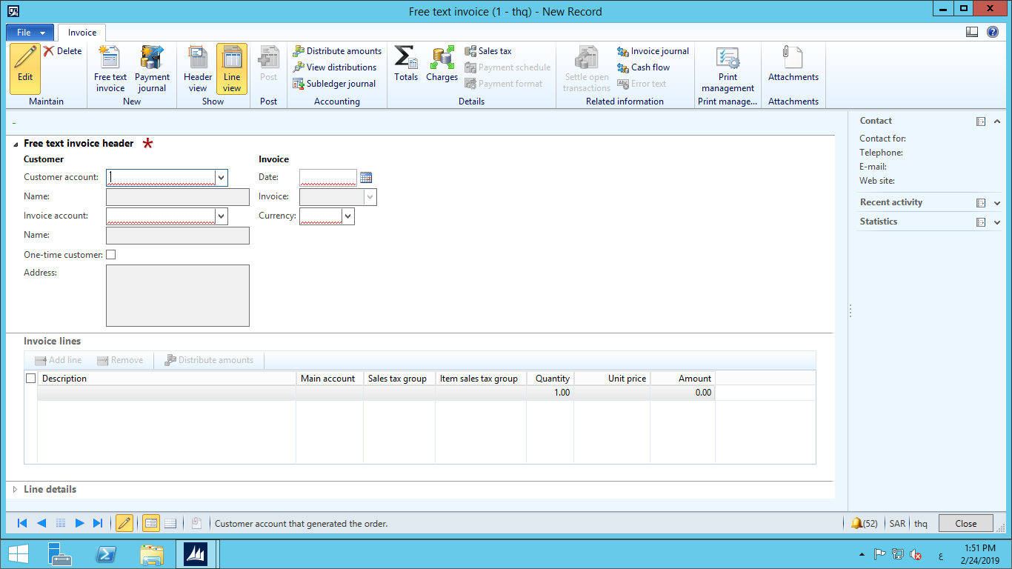



B. Bank reconciliation:

On monthly bases we reconcile between bank account and our bank account in ERP. We generate the bank statement from bank website and compare it with company book that I drag it from ERP system and do the necessary adjustments. After that we prepare the related form to be assigned by CFO. 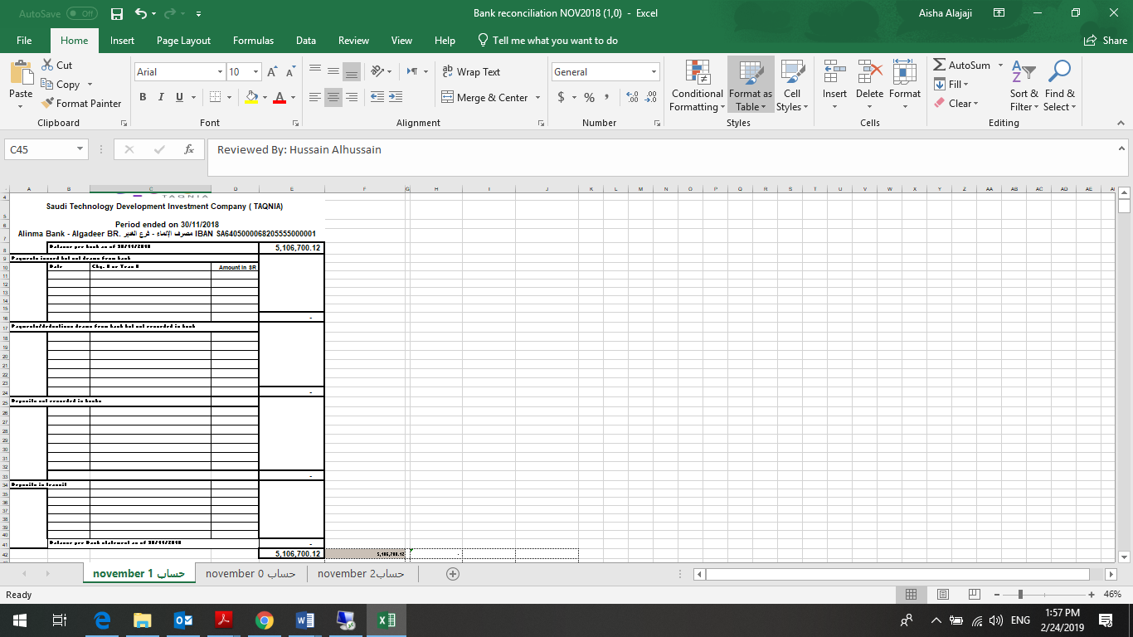
- Fixed asset:

- Depreciation:
Depreciation is allocated on a systematic basis over the useful life of the asset or its component and reflects the pattern of economic benefits from the asset. The depreciable amount is the cost of an asset or other amount substituted for cost, less its residual value. Depreciation charges are recognized in the consolidated statement of income. Depreciation starts when the asset is available for its intended use (e.g. when it is in the proper location and condition necessary to be used as intended). Depreciation continues even if the asset becomes idle or is retired from active use, until the asset is fully depreciated. Kind of assets that we depreciate each month:

Lands
Buildings
Vehicles
Furniture & Fixtures
Telecommunications
Electrical Equipment’s
Computers & Network
Tools
Software

So, at the end of each month I do the depreciation as follow:

- VAT & Withholding Tax:
- VAT
In my first week I was assigned to fill in the form for VAT which they must to submit it to GAZT website each month by taking sales invoices of projects established in that month and calculate 5% VAT, this part is standard rate domestic sale(output). Also, take purchase invoices from procurement department and calculate 5% VAT standard rate domestic purchase (input). The net amount is by using this function (standard rate domestic sale – standard rate domestic purchase) will be the due amount. After that I have to submit the form in GAZT website before the due date. By fill in the empty space for number and the system automatically calculate the net VAT and insert the VAT form attachment that I already did. I repeat this work by the end of each month.
On 22 of December I had a meeting with CFO and members from Alaziq office which is a company that ,,,,,,,,,,, 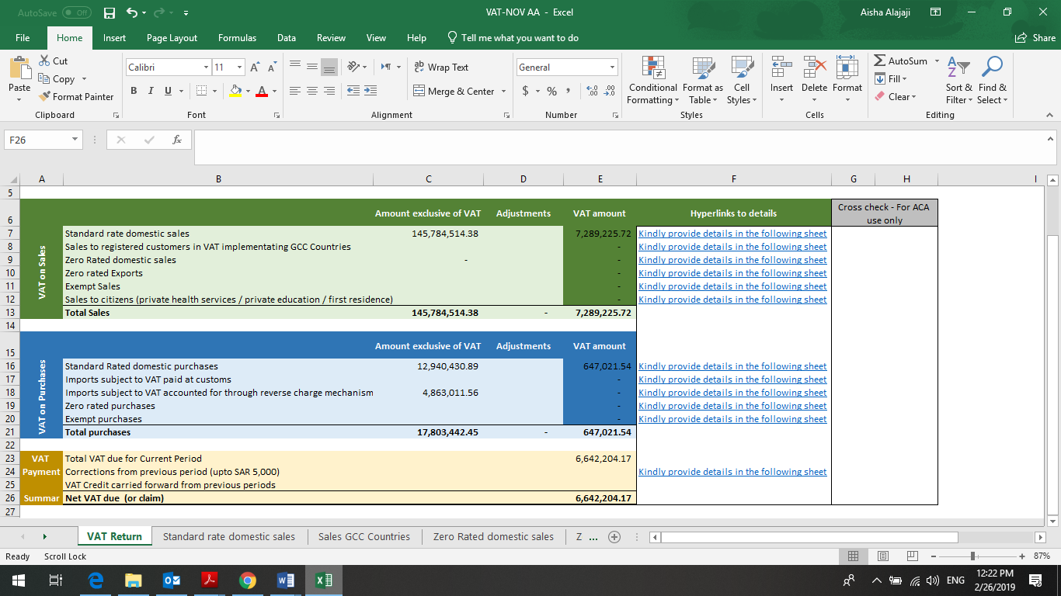
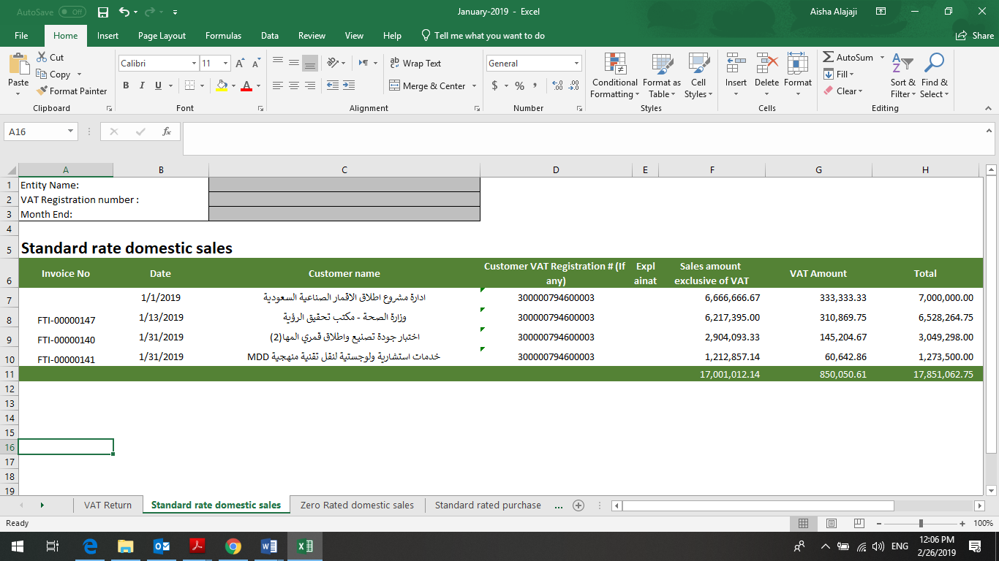

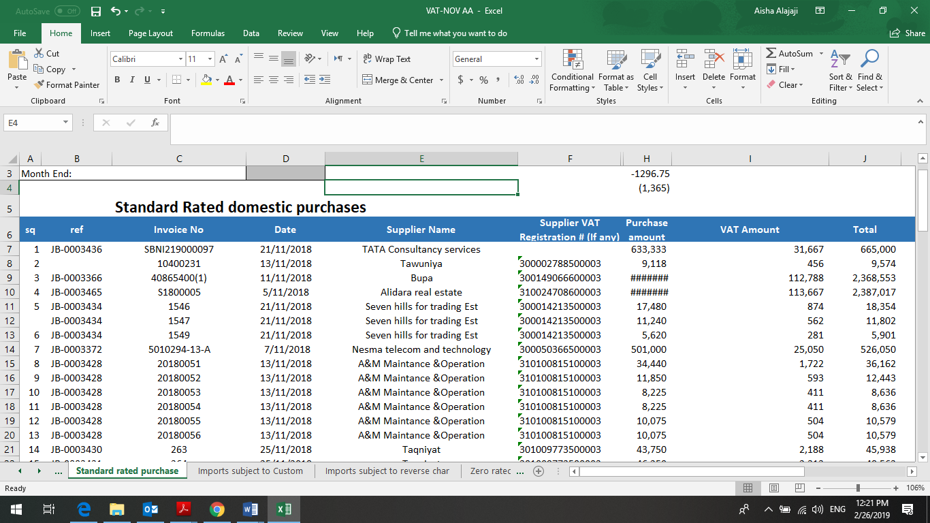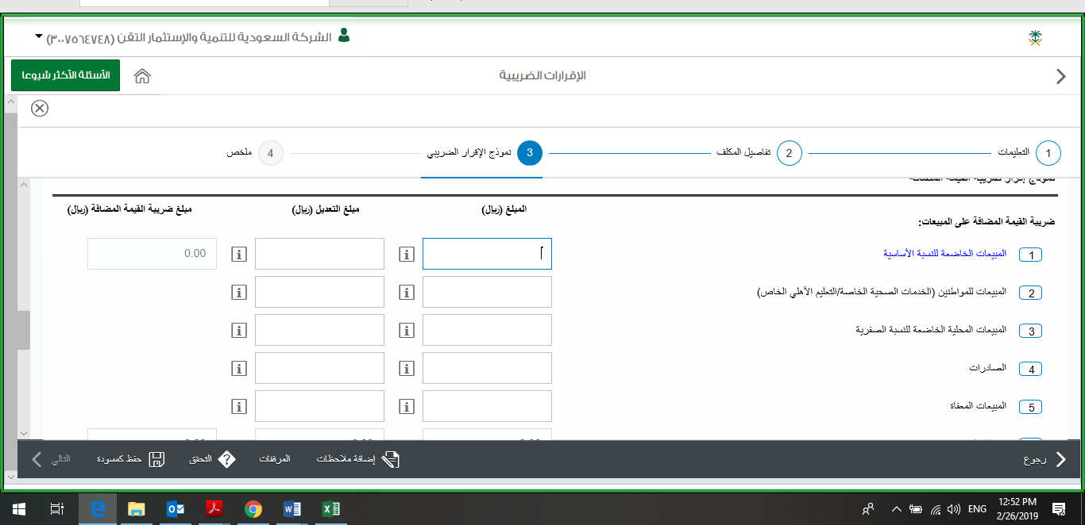

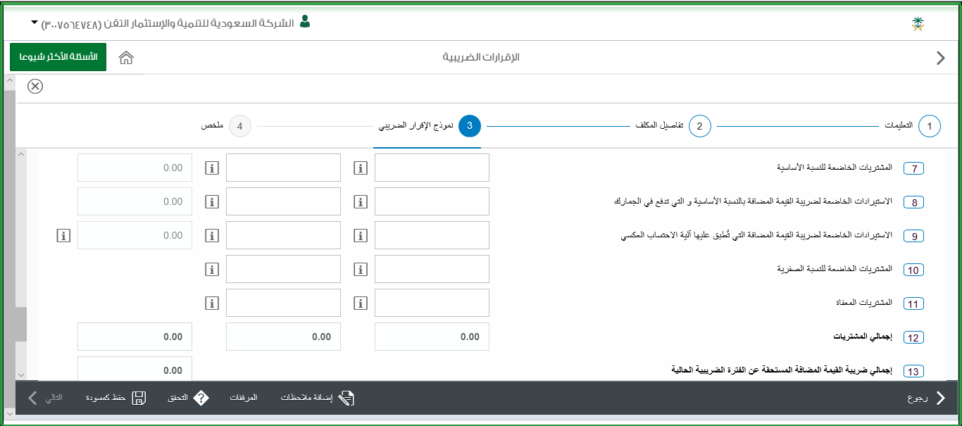

- Withholding tax:
Also, one of my tasks that I have to work on it is withholding tax. we exempt withholding tax from external bills that come from procurement department at the end of each month. After that I open the excel sheet form for the withholding tax and I multiply 5% from all the final amount of each external bill then submit it in GAZT website by fill in the empty space for each amount of external bill and the system automatically calculate 5% then attach the excel sheet form that I already did it. Finally, they send me notification of receipt of withholding tax invoice that we have to pay by CFO before due date from company’s bank account.
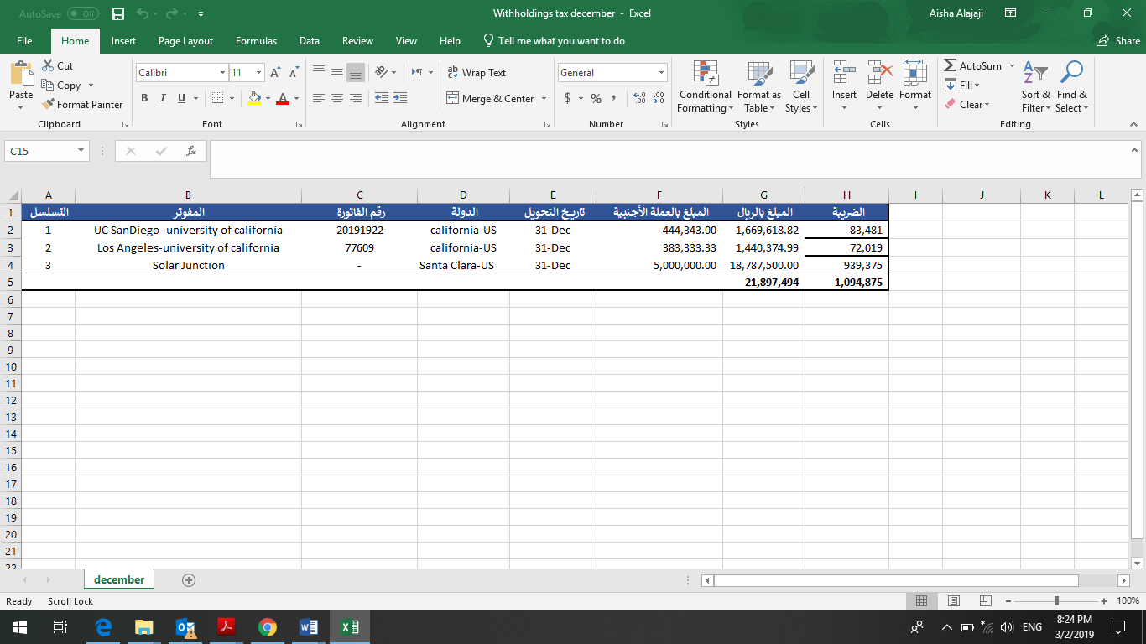
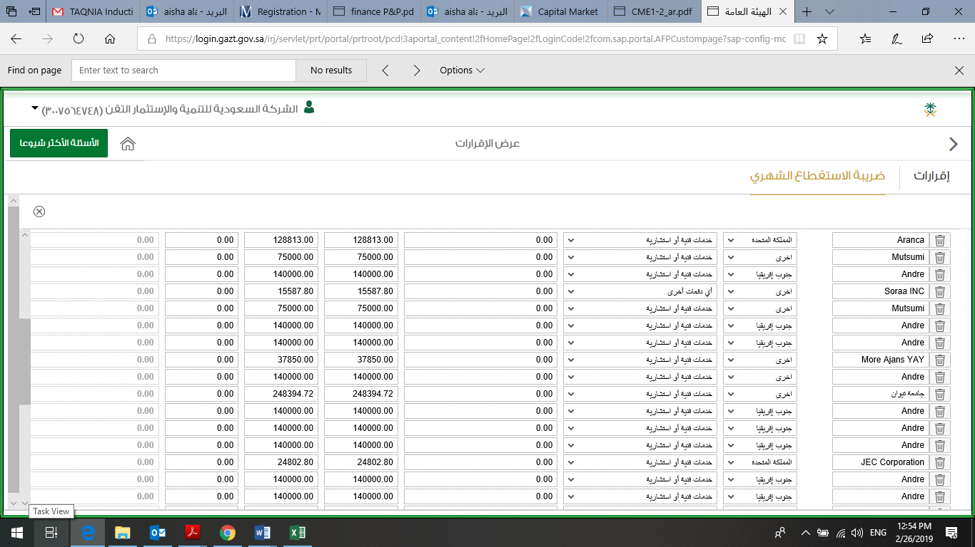

Other activities:

- Day to Day Tasks:

I Must admit that the small things make the biggest difference and looking back to the minor tasks I handled has proven to me that they can shape a person in ways she did not think would. The small tasks that were assigned to me were various, and different team members provided me with input whenever it was necessary. For example, I would constantly update excel files that we needed for upcoming invoices for old projects with the help of my supervisor, Also, reviewing different contracts and handling the department's emails.
I came to the realization that every single detail you go through, and every small role you play has an influence on a greater extent and taking those small responsibilities does shape your path. The small tasks I was in charge of were not directly related to my major, but they did teach me discipline and improved many of skills tremendously.

- ERP:

I was informed to read the user manual for ERP System. Taqnia Holding has decided to move to latest offerings in the Enterprise Resource Planning (ERP) arena for its internal information technology systems to handle their Finance, Inventory Control, Services and Logistics requirements. This system helps Taqnia holding to streamline their business processes by offering standard best practices being followed across the world. All the functionalities like Finance, Purchase, Payables, Sales, Receivables, Fixed Assets, Projects, Service Management and Inventory Management etc. can be handled in this system as a single application with tight security control and integration features.so I work on General Ledger. In Bank module we can manage the different bank accounts and bank groups. all the transactions/events taking place in any of the modules (example inventory, purchase/payables and sales/receivables) having financial impact (whether directly or indirectly related to general ledger) will be reflected in general ledger. For example, I do General journal which I use for entering or posting of daily transaction.
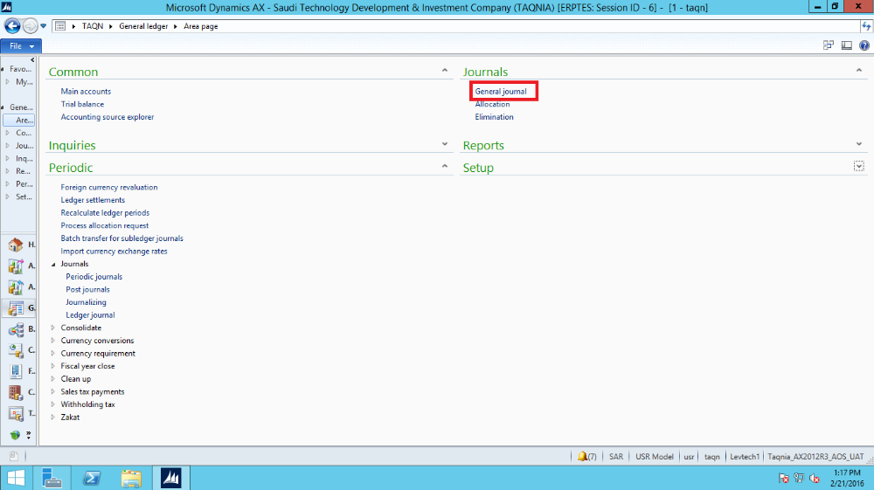

. Field Experiences
- Achievements
I am grateful and thankful for this opportunity to work at TAQNIA and be part of their wonderful team. It has been very rewarding on a personal and professional level. Throughout my journey in TAQNIA which was for seven months I have achieved many goals, the biggest was to exceed my supervisor’s expectations in delivering my tasks and reports on time and making her rely on me in many things. also gained a lot of skills and knowledge that will help me in the future to have a successful career. Throughout my journey I met wonderful girls who I became friends with, it is a great privilege to have friends who you can count on even in work. To be able to attend meeting during my coop training is an achievement I am grateful for. Also, I learned to adapt to new environments, and construct and voice my opinions. As well as developing my time management skills, multitasking, and punctuality.

- Challenges
Even thou my experience at TAQNIA during the last four months was very
informative, full of learning new things and the people over there were very welcoming, but
as we all know there is no place or experience that is 100% positive. Even TAQNIA had
some negatives that I have faced during my seven months’ internship. The main and the most
important down side in my internship is that the Finance Department where I
spent my internship in wasn’t ready to have an intern, they did not have a clear plan for an
intern, that’s because the Finance department is a very sensitive depart were
all the subsidiaries and holding payments and all the contracts and agreement are processed there. With that in mind I managed to gain my manger and the team’s confidence, and they
started giving more tasks to help with. During my Coop I faced some challenges which helped me to refine my personality. Another challenge is getting used to the fast-paced corporate environment, and dealing with people from different cultures, but with support of my colleagues I was able to fit in and improve my professional and communication skills. A very difficult challenge was that supervisor took maternity leave for 4 months, and at the beginning it was hard for me to work without my supervisor’s guidance, but this helped to depend on myself and build self-confidence and in those moments I learned that I can figure out things by my own either by googling it or reading similar work done or go around and ask for help not necessarily from my team.

- Relevant Education

ACC230 | Intermediate accounting for finance
CS 202 | Computer application for business
FIN 470 | Cases in financial management
ETHC351 | Legal Ethics
BUS495 | Strategic management

During my time in Prince Sultan University has built the right skills I needed and taught me the most useful knowledge in me. Which only pushed me further towards a path of success as an intern. From my first year at the University until the last year, my courses were noticeable assets in my journey and I would not have accomplished what I have accomplished without them. Of course, there are so many courses that were beneficial I didn’t mention, but here are some of them I’m glad I took. In finance department a lot of new concepts have been taught to me but because of the courses listed above I already had a brief background of the finance in general which made it easier to build on my existing knowledge. I relied mostly on what computer skills I have gained from the CS202.

V. Conclusion

To conclude, I really appreciate and recognize the benefits of the Coop program where I have grown and evolved through having the opportunity to train and interact in a real work environment. This experience has been valuable and beneficial in each and every way no matter which career I will pursue in the future.
- Overall Experience

I will always feel fortunate to have undertaken my training at TAQNIA, as it was an experience that I will never forget. I had the opportunity to learn from knowledgeable individuals who were welcoming and friendly, they had the tendency to offer help and guidance as much as I needed. I had acquired and developed plenty of new skills as well as enrich my technical, professional, and personal skills throughout this period. This experience gave me exposure to the actual business environment, which will help me to build the career life that suits my study field as well as my interests

- Recommendations

- Think carefully about what field you want to build a career in. it is important to love what you are doing.
- Find a company that tailors to your interests and search it as deep as you can to make sure it fits your preferences.
- Ask questions. You will learn a lot from people who work with you as they have more experience than you do. This will help you to deliver more efficiently and effectively.
- Deliver the reports to your advisor on time. This will help you to keep record of all your achievements.
- Manage your time, and always keep a list of the things that should be done with items of high priority first. It can be very challenging to manage your time in the first days of your professional career.
- Always be patient, helpful, social and the most important a person who is ready to learn.
- Show your enthusiasm, always ask to participate in tasks and projects, don’t wait for works to be assigned to you.
- Finally, start working on your final report and presentation early. Don’t leave it until last minute. It will help you to focus and mention all what you did and achieved during your Co-Op.

References:

https://www.taqnia.com/en/

